Request for Quote
Patient Specific Implants

Please send:
- Completed “Request for Quote” form
- CT Scan/Optical Disc from radiology (with scanner type, date of scan, patient name/number on disc)

Mail to:
Attn:2F, Unit 01, Building A, Haikexing Industrial Zone, Jinlong Avenue, Pingshan New District, Shenzhen City, Guangdong Province, China

Surgeon and Shipping Information: Patient Specific Implants and skull models must be shipped directly to surgeon; Please indicate exact name and location for model and implant to be shipped.

Surgeon name Hospital name /Account number
Phone number E-mail address
Secondary contact information (name, e-mail address, phone number)

# Ship to Account, attn:

# Other: (address, city, state, zip)

Patient number / name Date of planned surgery

Implant Information
suggests that surgery not be scheduled until Double Medical receives the product and the surgeon completes design validation.

Patient name* |  | Planned surgery date
Patient ID number* | Scan date*
Implant material:* | ❏ Titanium
Design validation method (choose one):* | ❏ Skull model | ❏ CAD images via e-mail
Description of defect(location, size, quantity)*

Approximate defect location and shape (please draw/annotate defect)
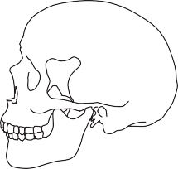
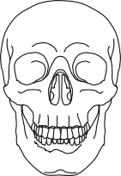
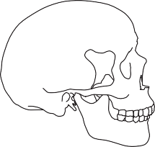
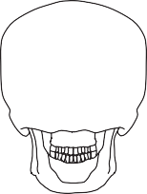

*Denotes required fields

